**TSU CELEBRATES THE LEGACY OF TRAYVON MARTIN**

By: Adonis Warren

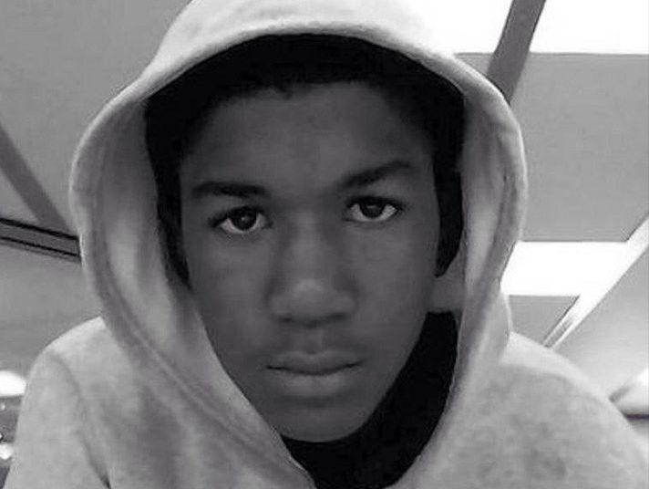

Another black boy becomes ancestor…  
  
With what would have been his 24th birthday on the 5th of February has turned into a day of mourning and reflection. The nation is remembering the life and tragedy of Trayvon Martin, a death that sparked controversy and forced Americans to ask the question- have times really changed? This horrific event took place in 2012 and has set the tone for mass distrust of the criminal justice system.

In celebration of Martin, TSU’s Student Life, Beta Delta Chapter of Phi Beta Sigma Fraternity Inc., and the University Program Council presented Take Back the Mic. Hosted by nationally ranked Self the Poet, the event went spectacularly. The energy was intense as students were thoroughly entertained by some of TSU’s best talent, along with various vendors being recognized for their up and coming businesses in hair and fashion.  
  
As soon as the elevator doors opened, tunes from the latest artists are blaring out into the hallway, heavy music pulsating the room. With only a handful of occupants in the area, there was still a lively atmosphere as the DJ, hosts, guests, and vendors prepared for the night. Many broke out in dance and freestyled till their hearts desired. Exactly 15 minutes after eight o’clock, a crowd of students stepped in and the energy in the room skyrocketed. As I sat to the side, I realized quickly that the turnout will surpass my previous expectations. As 30 minutes past, a steady flow of people began to fill the seats as the show started.  
  
Beginning on a high note, Self the Poet introduced the audience to the importance of this day: the birth of Trayvon Martin and his memory. He stated, “The country is in dire need of black people to get together.” He then performed for us his own poem surrounding the inappropriate use of the word “nigga” by Caucasians. His spoken word sparked quite a few other poets in the room to share their poetry on police brutality, social injustice, and racism. A few poets strayed and talked about love and relationships. In-between those performances, we enjoyed popular throwback hits of the 80’s and 90’s, putting the audience in a jovial mood.  
  
Later, inspired by obstacles in her life, a female student graced us with praise dance and towards the end we were serenaded by an original song by DJKew, which caused quite the hysteria amongst the crowd. Minutes before the clock struck ten, the celebration continued on with more dancing, rapping, and the intertwining of students of all ages and class ranks.  
  
Lest not forget this event was more than just a merriment of black people gathering together- it was about celebrating a life who could no longer do so himself. A life that was unjustly taken. “Another black boy becomes an ancestor”, as one poet expressed; a black boy who became part of our history. Let us remember Trayvon Martin and the many others who have been unjustly murdered and remember their life and legacy because they are our black history.