**TSU hosts Hackathon that blends education and fun**

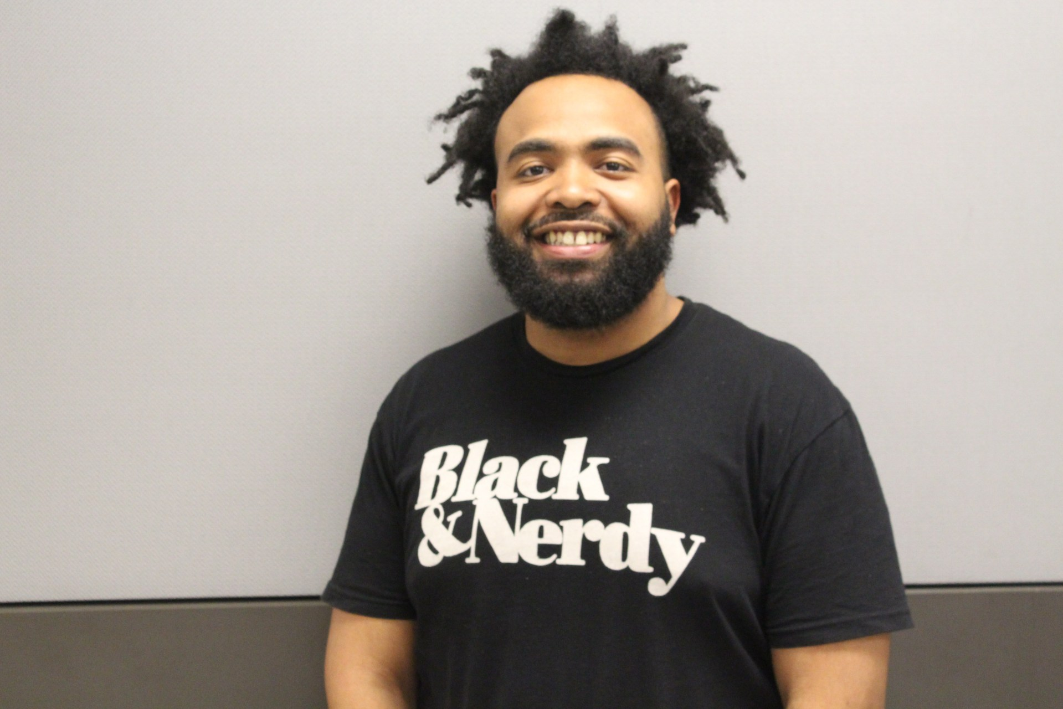

**Written by: Adonis Warren**

On Friday night, Elvis Tran went to sleep on the floor of room 156 in the University Science Building. He didn’t bring an air mattress but he did bring his self-built computer and a Playstation.

But he wasn’t the only one. Around a hundred tech and non-tech students from all over Houston gathered overnight, April 13th-14th, for the 2019 Houston Hackathon– a 24-hour competition where students brainstormed ideas, built software/hardware, ate Chinese food, played video games and presented their ideas in front of judges on the final day.

Some spent the entire night in costumes. One dressed up as a llama.

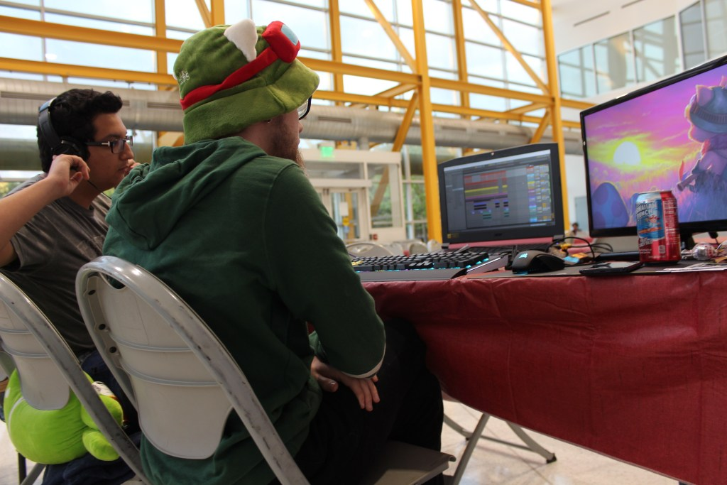

The Hackathon, which happens in cities across the world, was put together by Texas Southern University’s Computer Society and sponsored by Major League Hacking, Roku, and Microsoft.

Hackathon participants were required to come up with an idea and build it, or write the code, within the 24-hour timeframe to then demo in front of four judges at the end. Participants were allowed to choose their own groups (maximum of four in a group), and work on the project only within the timeframe of the Hackathon.

There was also plenty of time to play videogames.

Lentynie Tran, a senior physics major and president of the Texas Southern University Computer Society, believes bridging the gap between education and fun is what Texas Southern needs. She believes the Hackathon achieves just that.

“This is what students want and what needs to happen at TSU,” Tran said. “Hackathon is a big thing and it can change the culture. We can’t just have events that are ‘Oh, cool, social outgoings’. The social events are great, but if you don’t have educational events that actually teach you outside of the classroom, then what is it all for?”

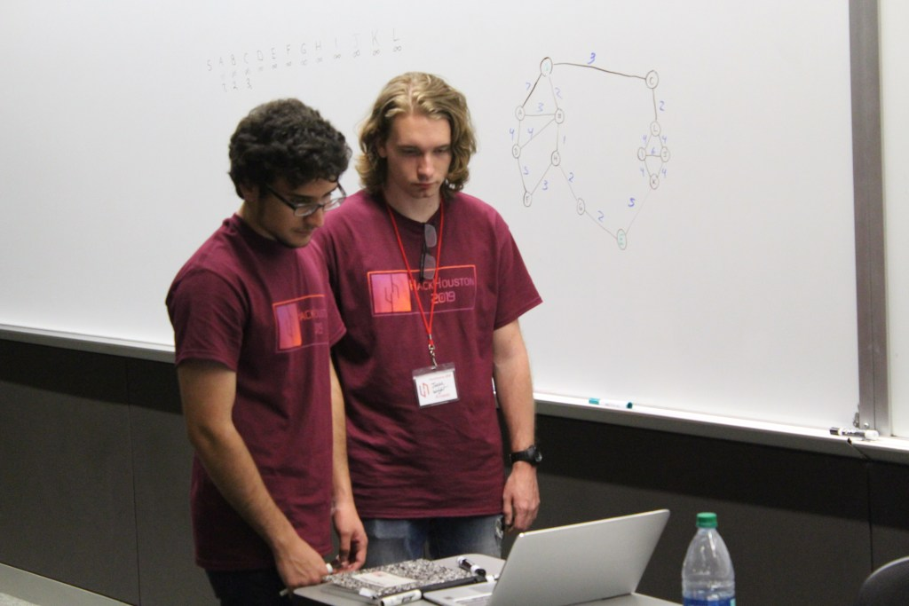

Over a hundred Texas Southern students signed up for the event, according to Tran, but only about a dozen showed up. Although this is the first Hackathon hosted at Texas Southern, it counts as a significant milestone for introducing events that are both educational and entertaining for students.

“Organizing events for students with technological educational pursuits is hard. Especially when it’s like a twenty-four hour Hackathon,” Tran said.

Although students weren’t formally learning in the classroom, they were definitely sleeping in them.

“The students had air mattresses so [Elvis] didn’t have to do that. That was on him,” Tran said between laughs. Students slept in lecture halls, campus police vehicles, student offices and wherever else they could find in the Science building.

Some didn’t even sleep. By the time the students were preparing for the judging of their inventions, a few students had to take power naps before their presentations.

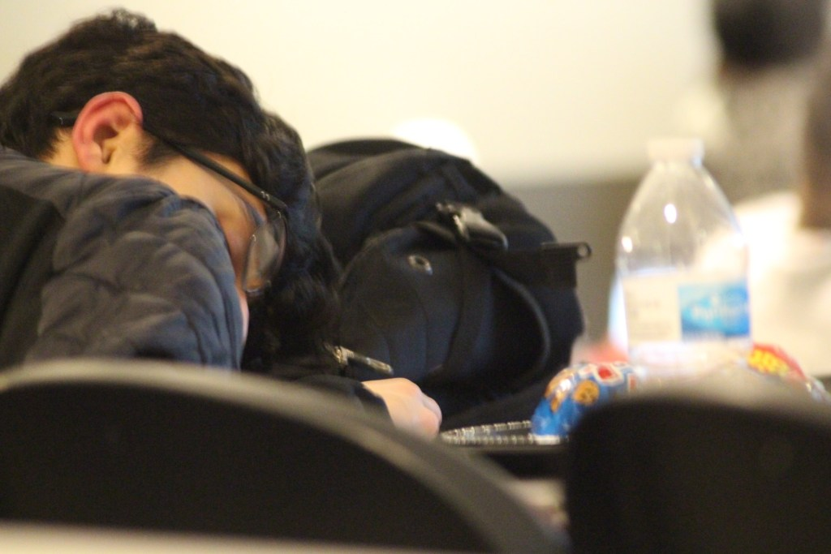

The judging was based on each invention’s potential effect on society, the short-term and long-term application of the project, the project’s creativity, design, user experience, ease of use, and problem-solving ability.

The inventions ranged from phone apps to social media movements; a diverse group of inventions that were indicative of the diverse group of students who participated.

One group created Cleanspace, a web application that focuses on building community awareness by uniting others to create cleaner spaces.

“We got the inspiration from the TrashTag challenge and we realize the lack of centralized information about it,” Melanie Villela said, one of Cleanspace’s co-creators. “So we decided to create a platform where volunteers can gather together and beautify public spaces.”

Another project, which was one of the winners, was a Malaria Scanner: a free web service that can be used to aid in the early detection of Malaria. It’s supposed to save the cost of healthcare and the problem of short-staffing at medical facilities in many developing countries.

The winner was a project called Edunate: a platform that allows people to micro-donate to students for their academic needs, helping others by tutoring for classes and other essential tools students need.

They came into the hackathon “wanting to solve an actual problem college students face throughout the world,” described one of the project’s creators.

“One thing [we] observed was that lack of money is one of the biggest reasons college students either don’t achieve their goals or are hesitant towards risks. We wanted to solve that.”

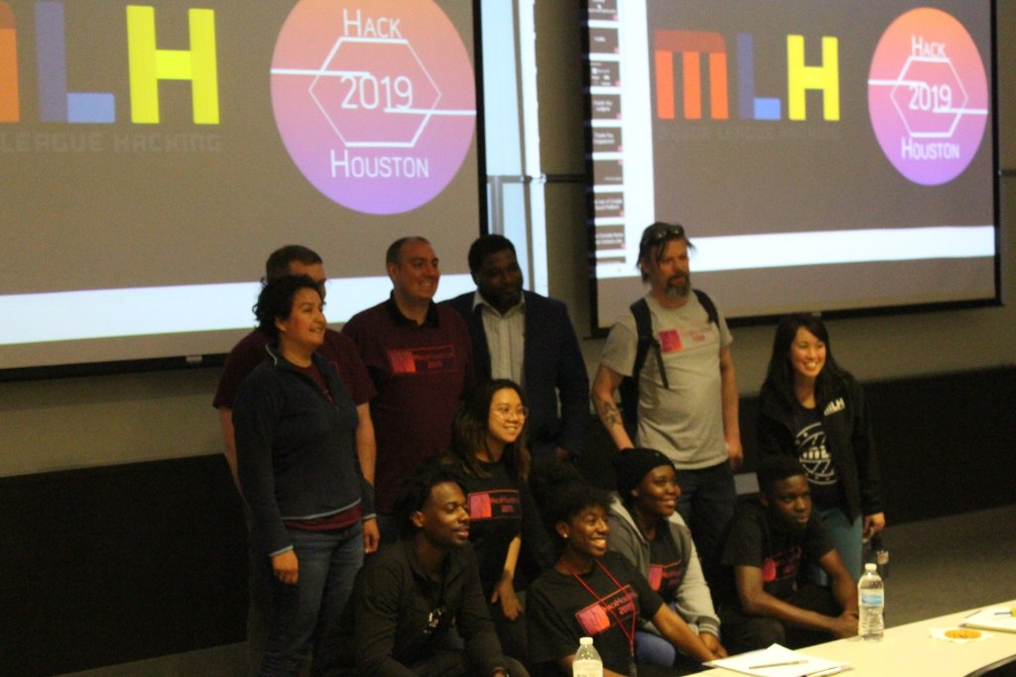

Prizes included Nintendo Switches for each member of the winning group, Google Home Minis, JBL Speakers, and much more.

“I think it went really awesome. The organizers put in a lot of hard work,” said Mary, a representative for Major League Hacking.

Although it was a success, Tran and the Computer Society definitely want more Texas Southern students to show up for the next one.

“If we expose ten students to ninety different students and they see there is another community of students out there,” Tran said, “then we have done our job.”