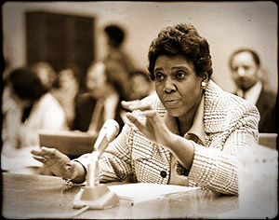

The Qualities of Barbara Jordan

                       By: Adonis Warren

Barbara Jordan, a U.S. congressional representative from Texas and was the first African American congresswoman to come from the Deep South, Fifth Ward Houston Texas.

As an African American being a lawyer, an educator, a congresswoman, and the first black woman to be elected into the Texas Senate meant more than a title. After working on the president with a speech and creating things like the “Texas Fair Employment Practices Commission “opened many doors throughout Ms. Jordan’s life.

Barbara Jordan stood for many things and took care of many legislative matters. In today's society immigration beliefs, and rights are debated amongst political parties. One question that is asked frequently, reads “What was Barbara Jordan stance on immigration and does it match with Donald Trump’s”. Barbara Jordan said a quote that reads, “Illegal Immigrants should not be entitled to the same benefits of an American citizen “. This quote explains her thought and mindset on immigration.

Donald Trump currently serves as are 45th president of the United States. His stance on immigration happens to be similar to Barbara Jordan. The difference between Barbra Jordan Stance and Donald Trump will be the way is expressed, and the certain comments that are made.

Barbara Jordan made it clear if you were in then you were to stay along with being kept out means to remain out. Ms Jordan believed it was the responsibility of the democratic society to manage immigration. If the Democratic Party managed immigration it would strongly serve the national Interest. Ms Jordan was a person who believed in equality and stood for a fair chance. She has gave many speeches and made it clear she was there to serve the people.

Donald Trump feels as if immigrants should not be allowed. Donald trump used his presidency to keep immigrants out of America. One plan he implemented was the building of the wall. This wall was designed to keep immigrants from coming into our country, in his words “stealing are resources”. There are things taking place such as the Dreamer Acts that was started to immigration.

Both, Donald Trump and Barbara Jordan took different approaches on the topic of immigration. In reality they both have the same stance. Barbara Jordan is a person who was fair and opening minded to her beliefs on immigration. She understood how immigrants felt but she went by the rules and nothing more.